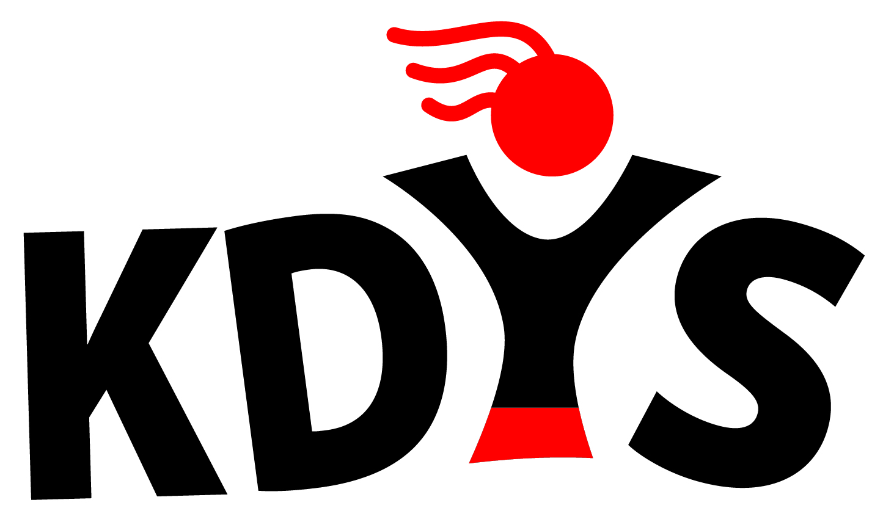
KDYS Youth Justice Worker
Job Description

Title of Post: KDYS Youth Justice Worker
Location: TBD
Reports to: KDYS Co-ordinator

About KDYS Youth Justice Work
KDYS has a long history of developing innovative responses to the needs of young people that enhance their lives, their families and the wider community. In partnership with the Kerry Gardaí, we commenced a pilot project in 2013 which brought our existing six youth crime diversion projects together to work as one unit, to more effectively respond to the dynamic trends of youth needs across the entire Kerry Division.
This new service response is based on clear evidence of need informed by Garda crime statistics. The net result is that young people who are most in need of a service will get that service.
The project is funded by the Department of Justice and Equality and the European Social Fund.

Qualifications/Experience:
- 3rd Level Degree (Level 8 or equivalent) in Youth Work or a related field
- Have experience in devising, implementing and evaluating programmes/ interventions/responses for ‘at risk’ youth
- Have experience in providing support for ‘at risk’ youth to take positive steps which would enhance their education and employability.

Principle Role and Responsibilities
- To operate to KDYS Core Values: -
  - Young people at the heart of everything we do
  - Concern for the young person’s development, personal, social, educational and spiritual
  - Commitment to partnership with young people, volunteers, communities and funders
  - Upholding quality standards of integrity and professionalism.

- To participate fully and work effectively within the KDYS Youth Justice Team
- To develop a needs based response to ‘at risk’ youth, through face to face work to prevent involvement in crime
- To engage in outreach work to identify young people for inclusion in the project through the Referral Committee
- To develop and maintain relationships with "at risk" young people on a one to one basis
- To engage with relevant services and supports to facilitate a community response to the needs of young people
- To devise, implement, document and evaluate all programmes/interventions in line with KDYS requirements
- To complete, develop and review assessments and case plans for young people.
- To support and motivate young people in their identified progression paths.
- To prepare monthly reports for supervision.
- To prepare progress reports and annual reports as required.

Person Specification
Essential Criteria
- Experience in working with young people in a dynamic/engaging way using a variety of methodologies used in Youth Justice Work
- Track record in designing, delivering and evaluating programmes for ‘at risk youth’
- Proven experience of working effectively in a team environment.
- Proven ability to work on one’s own initiative.
- Experience of using strong interpersonal skills (written and oral) across a diverse and wide audience
- Experience of having worked with multiple time demands and deadlines, exercising judgement on time management & level of attention to detail
- Analytical skills with the capacity to absorb/organise new information to ensure well briefed on new topics
- Comfortable taking decisions within a clear framework of delegation

Core Competencies
- Change Orientation: Ability to work flexibly in a changing environment.
- Continuous Development: Drive to achieve excellence and continuously develop oneself, one’s team, the organisation and the Young People on the Programme through learning and knowledge sharing.
- Valuing Diversity: Openness to working effectively with diverse ideas and people.
- Organisation Commitment: Meets the standards of behaviour and professionalism required to operate effectively in the KDYS.
- Analytical Thinking & Decision Making: Think logically, analyse complex information, identify key issues and make effective decisions, taking accountability for decisions made.
- Communication & Interpersonal Skills: Conveying information clearly in both oral and written form, effectively communicating one’s views by negotiating and influencing others at all levels.
- Resilience: Demonstrating the confidence and ability necessary to cope with challenging situations.
- Task Management: Ability to prioritise and manage tasks effectively so as to deliver required outcomes to agreed standard.
- Team Work: Ability to work effectively & co-operatively as part of a team and demonstrating commitment towards team goals.

Health
- A candidate for and any person holding office must be fully competent and capable of undertaking the duties attached to the office and be in a state of health such as would indicate a reasonable prospect of ability to render regular and efficient service.

Character
- Each candidate for and any person holding the office must be of good character.

Other
- Car Owner with full clean driver’s license.

Requirements of all KDYS Staff:
- Commitment to the purpose of KDYS and to work within the values, policies and procedures of the organisation and in the context of current legislation and regulations
- To report any area of concern to your line manager in a timely fashion
- To show flexibility in relation to hours of attendance to meeting the need of the work.
- Have a flexible approach to the work in response to organisational change, development and review of best practice
- Identify training needs through your supervision and participate in training opportunities appropriate to the role
- To be vigilant to any Health, Safety and Welfare risks in the workplace and bring any concerns to your line manager or Health & Safety representative
- To undertake other duties as may be requested by the line manager from time to time
- To undertake your work in a manner that is friendly, flexible and professional

Contract

Tenure: | Special Purpose Contract linked to Career Break Cover
Salary | Point 1 of CDYSB “New Entrant” Youth Worker Scale - €28,479
Hours of work | 35 hours per week  Frequent evening & occasional weekend work

