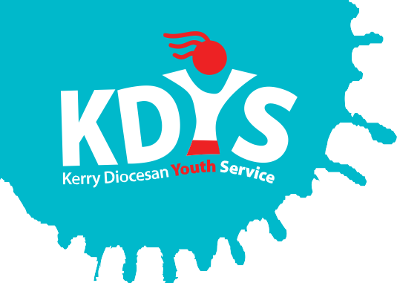
KDYS Youth Justice Worker
Job Description

Works With: | KDYS Team in Tralee and surrounding area
Reports To: | KDYS Co-Ordinator with responsibility for Youth Justice
Location: | Kerry Divisional Area

KDYS, the leading youth organisation in South West Ireland as affirmed by the Council of Europe awarding the Quality Label for Youth Centres to our Killarney headquarters. We provide a range of quality services responding to the needs of children, young people, their families and communities.

About KDYS Youth Justice Work
KDYS has a long history of developing innovative responses to the needs of young people that enhance their lives, their families and the wider community. In partnership with the Kerry Gardaí, the service response is based on clear evidence of need informed by Garda crime statistics. The net result is that young people who are most in need of a service will get that service. In 2019, the KDYS further developed the KEY Service to extend to a limited delivery to children aged 8-11 years old. Over the last 12 months the KEY Service have engaged in a co-design phase of an Action Research pilot to determine the most suitable response to engage with this younger age group.

Job Summary
Work with young people, their families, agencies and the community in the Kerry Division to develop and deliver suitable interventions and supports to young people in the area as per the funding criteria. The project is funded by the Department of Justice and Equality and the European Social Fund.

Key Duties & Areas of Responsibility will include:
- Develop a needs based response to ‘at risk’ children and young people, through using the appropriate risk assessment frameworks to inform face to face work to prevent involvement in crime.
- Engage in outreach work in communities, homes and schools to support work with young people and children and to identify young people for inclusion in the project through the Referral Committee.
- Develop and maintain relationships with "at risk" children and young people on a one to one basis.
- Engage with families, relevant services and supports to facilitate an appropriate response to the needs of children and young people we engage with through our work.
- Devise, implement, document and evaluate all programmes/interventions in line with KDYS requirements and Department of Justice Operational Requirements for GYDP’s.
- Complete, develop and review assessments, interventions and case plans for young people.
- To support and motivate young people in their identified progression paths.
- To participate fully and work effectively within the KDYS Youth Justice Team.
- To undertake administrative duties relevant to the position, including maintenance of records and provision of reports as required and/or as requested.
- Actively participate in both internal and external networks, structures and events relevant to the post.
- To prepare for and attend individual supervision on a regular basis.
- Ensure ongoing compliance with organisational data protection policy and practice in all aspects of the role.
- Support the KDYS planning and reporting processes.
- To undertake other duties as may be requested. This may include involvement in the organisations events, fundraising, research etc.

Special conditions
- A relevant professional qualification in youth work, community work, family support, social care, social work, childcare, education or other relevant discipline.
- Minimum 1 years relevant work experience. Voluntary Work Experience is valued.
- Experience in devising, implementing and evaluating programmes/ interventions/responses for ‘at risk’ youth.
- Experience in providing support for ‘at risk’ youth to take positive steps which would enhance their education and employability.
- Fluency in English, both written and verbal.
- Full, clean driver’s license.

Skills, competencies & attributes
Specialist Knowledge, Expertise & Self Development
- Experience in working with young people and or children (particularly with young people who present with complex needs) in a dynamic/engaging way using a variety of methodologies.
- Clearly understands the role, objectives and targets and how they fit into the work of the department and the wider organisation.
- Knowledge of issues and trends affecting young people and children in contemporary Ireland.
- Understands the boundaries of professional practice.
- Demonstrates knowledge of child protection policy and practice.
- Understands and shows commitment to the purpose of KDYS and to work within the values, policies and procedures of the organisation and in the context of current legislation and regulations.
- Reflects on and is committed to own development personally and professionally as well as the development of the work through engaging in required training and piloting new initiatives within the KEY Service.

Programme development and delivery
- Ability to design, deliver and evaluate programmes for young people and children with varying diverse and cultural backgrounds.
- Analytical skills with the capacity to absorb/organise new information to ensure continuing best practice.
- Demonstrates the ability to apply appropriate and relevant youth work and child-centred approaches and methodologies.
- Understands the importance of health and safety within the workplace overall and with emphasis on the delivery of programmes and activities with young people.

Delivery of Results
- Plans and prioritises work in terms of importance, timescales and other resource constraints, re-prioritising in light of challenging circumstances.
- Deliver on reporting requirements.
- Assumes responsibility for and delivers on agreed objectives / goals.
- Ability to achieve results through community networking and cross sectoral working as relevant to the role.
- Is self-reliant and uses judgement on when to seek guidance and from whom.

Teamwork
- Develops and maintains respectful working relationships with others, sharing information and knowledge, as appropriate.
- Maximises the contribution of the team, encouraging ownership, providing support and working effectively with others.
- Contributes to the development of policies in own area and the wider organisation.

Administrative & Technical Skills
- Experience in Microsoft Office (Word, Excel, Access & Powerpoint etc).
- Practical knowledge and experience of social media platforms commonly used by young people.
- Proficient in maintaining accurate paper and electronic record systems, capable of information retrieval, analysis and dissemination as required.

Interpersonal & Communication
- Communicates in a fluent, logical, clear and convincing manner verbally and in writing.
- Is able to listen effectively and develop an effective dialogue quickly.
- Is able to acknowledge and address conflict in an open, honest and non-judgemental manner.
- Ability to advocate for, motivate, and engage young people and children appropriately.

Drive & Commitment
- Is self-motivated and shows a desire to continuously perform at a high level.
- Has the ability to think logically, use initiative and work with minimum supervision.
- Have a flexible approach to the work in response to organisational change, development and review of best practice.
- Through leading by example, fosters high standards of ethics and integrity.
- Deliver support and learning to the team through peer support mechanisms.

Contract
- Fixed Term contract to 31st December 2019.
- This contract is for 35 hours per week
Your normal working week will be 35 hours per week. The nature of this post requires the holder is flexible in working hours to cover the operational times of the service and the centre. This will involve frequent evening and weekend work, at times when young people are available and/ out of school
- Salary scale applies.
- Employment with KDYS is subject to a satisfactory response from the Garda Vetting Unit being received in relation to any candidate under consideration and satisfactory reference checks being received.
- This post is subject to a 6 month probationary period.

